**Initial Design Phase:**

When we were in class and got to choose an object to use in our game we were not sure what to grab. We didn't want to be boring and grab the blocks or the balls so we decided to give the stretchy hair bands a try. Once choosing the bands we had to come up with a game idea. One of the qualities of the bands that we thought we would be able to take advantage of was there ability to be stretched with the fingers and shot at things. One original idea was to make a sort of dart board and shoot the bands at a bullseye for points. This idea quickly fell apart as we did not have any ideas for making the bands stick to the target other than those sticky rodent traps. We thought using the sticky tape would not be a good idea because we did not know if they were sticky enough to catch the bands reliably and we also thought that they would leave too much residue on the bands. Our next idea was to shoot the bands at wood blocks laid on a table and try to push them into a target circle, kind of like curling. We did some testing with this and found that it was hard enough to hit the blocks let alone have enough control to precisely move the blocks onto a target. While testing that idea someone built a castle out of the blocks and shot the band at it. And that's when we knew what are game should be. We settled on having two teams of two where each team build a castle with wood blocks and then takes turns trying to knock down the other teams castle. The scoring is based off of whoever has the most blocks remaining after a certain number of shots. In playtesting we know need to figure out how to best balance the game. Some of the factors we are focused on are how many blocks should be used to build the castle, the minimum height of the castle, and how many shots each team gets to try and knock down the castle.

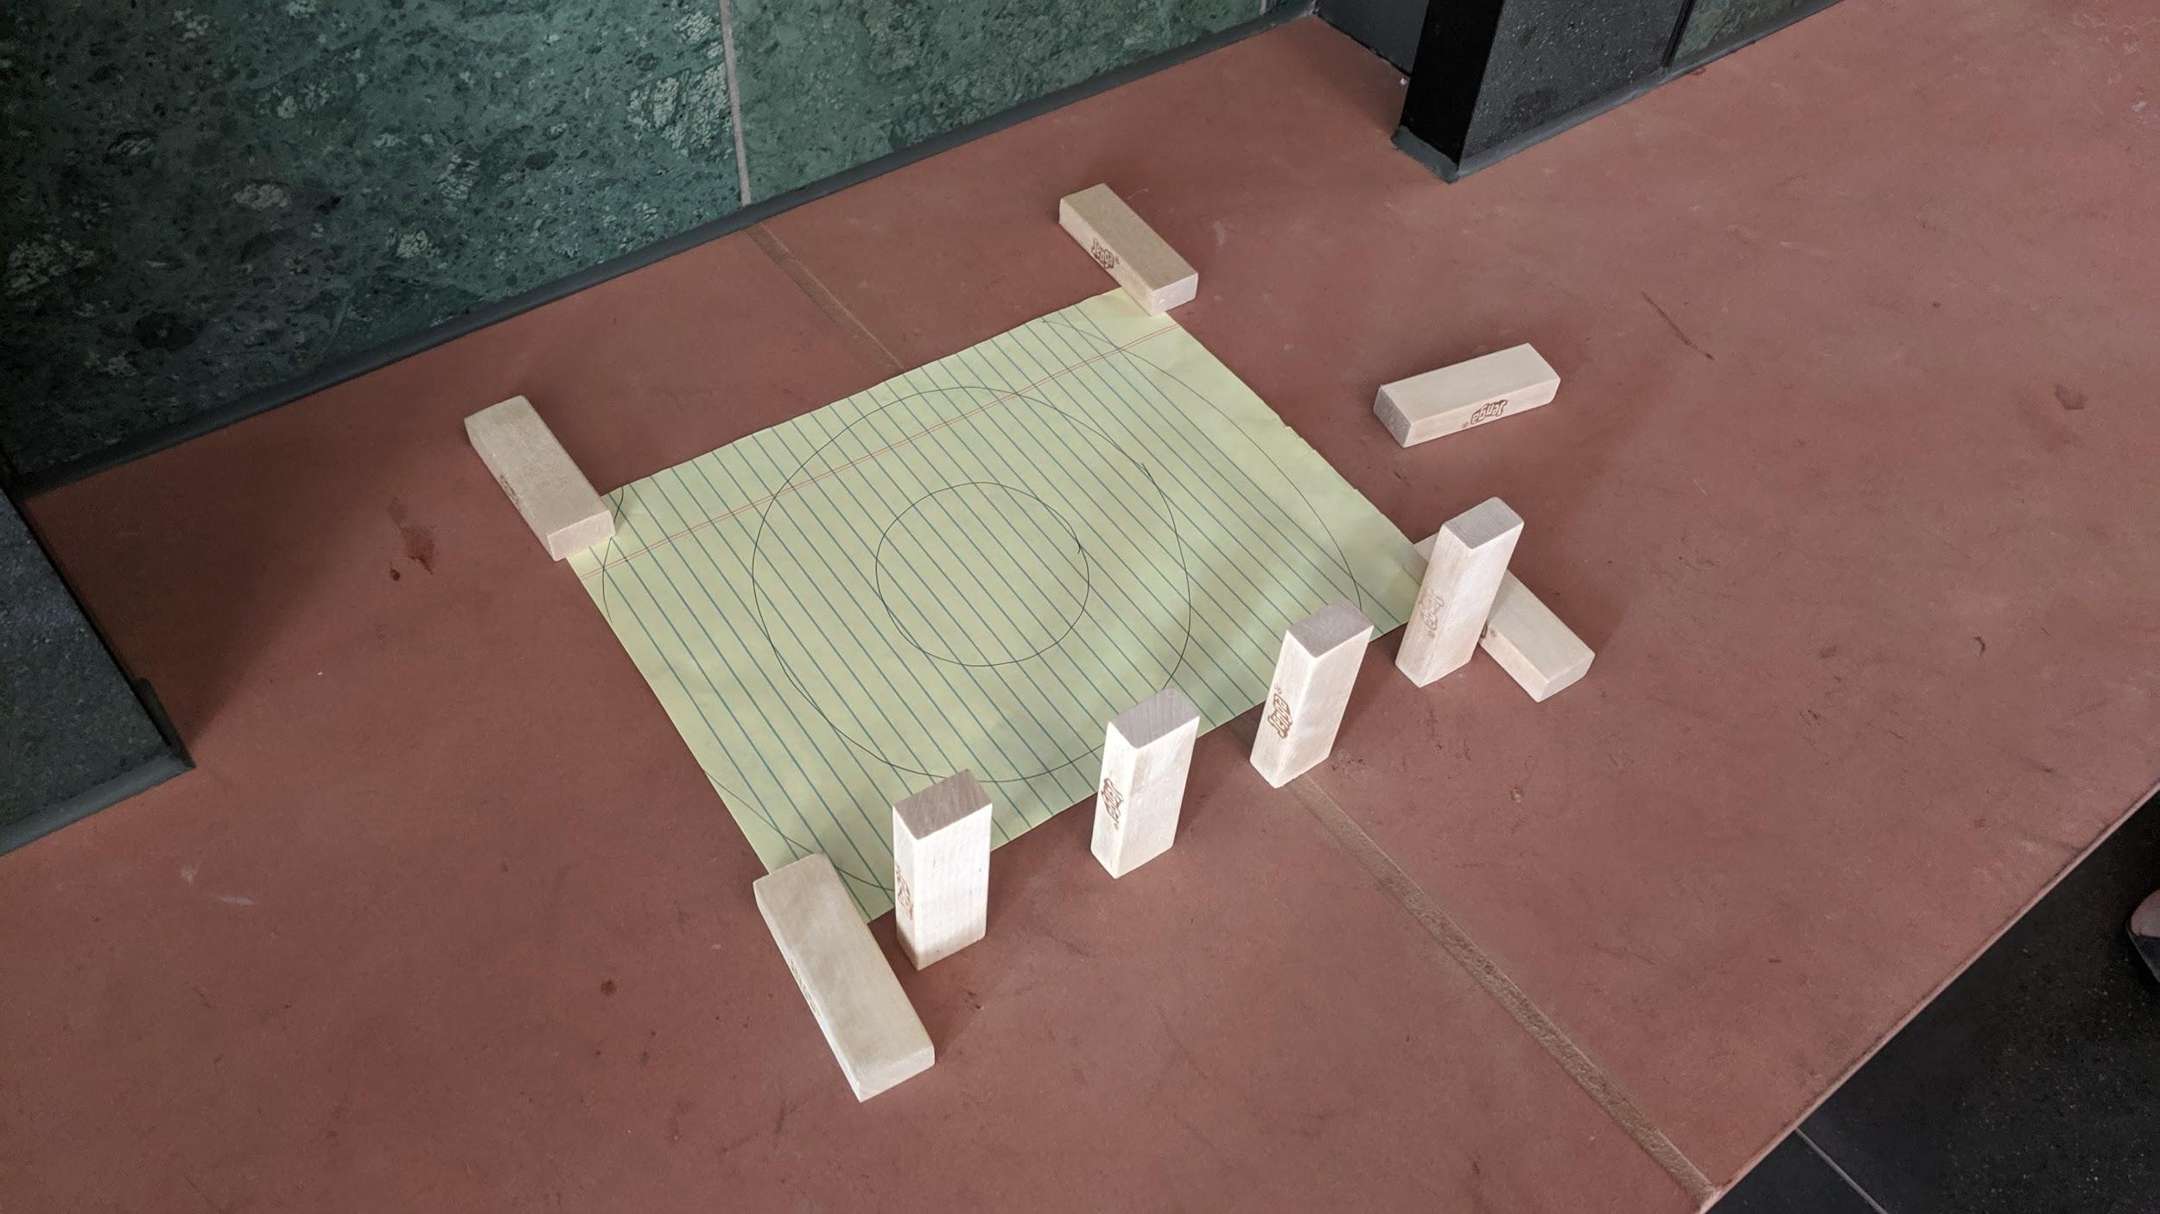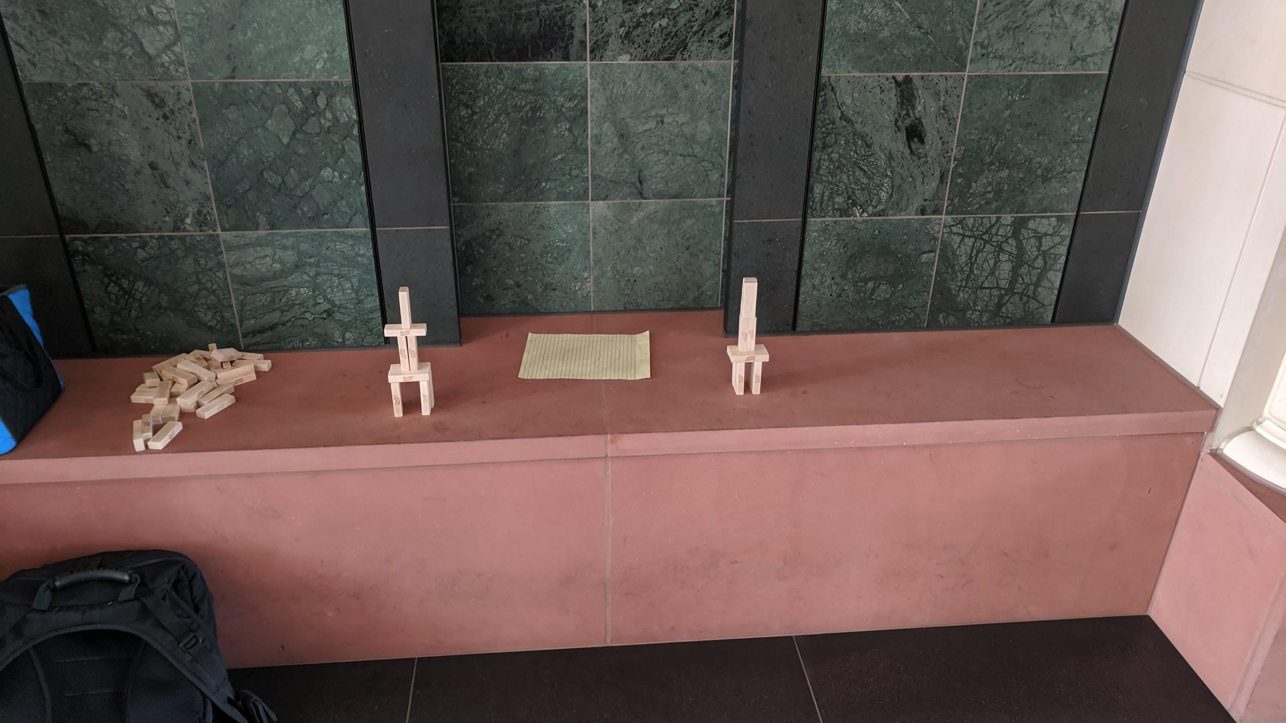

**Final Design:**

Our playtest answered a lot of our questions. For one people seemed to enjoy the game. We also decided that there should be 12 blocks per team to get the best balance. When we were watching other teams build their towers we found a loophole that people were using that gave an unfair advantage. Too many people were laying blocks down flat on the bottom level. We thought at first that counting those blocks as already fallen would be enough incentive for people not to do it. Turns out that is not the case. So we had to make a rule that disallowed players from having blocks lay flat on the bottom of the tower. We also realized that the design of our game needed work. So we made a nice looking box and also decided to paint the blocks to make them look more like a castle and castle walls. We feel this really added a good visual experience to an already fun game.

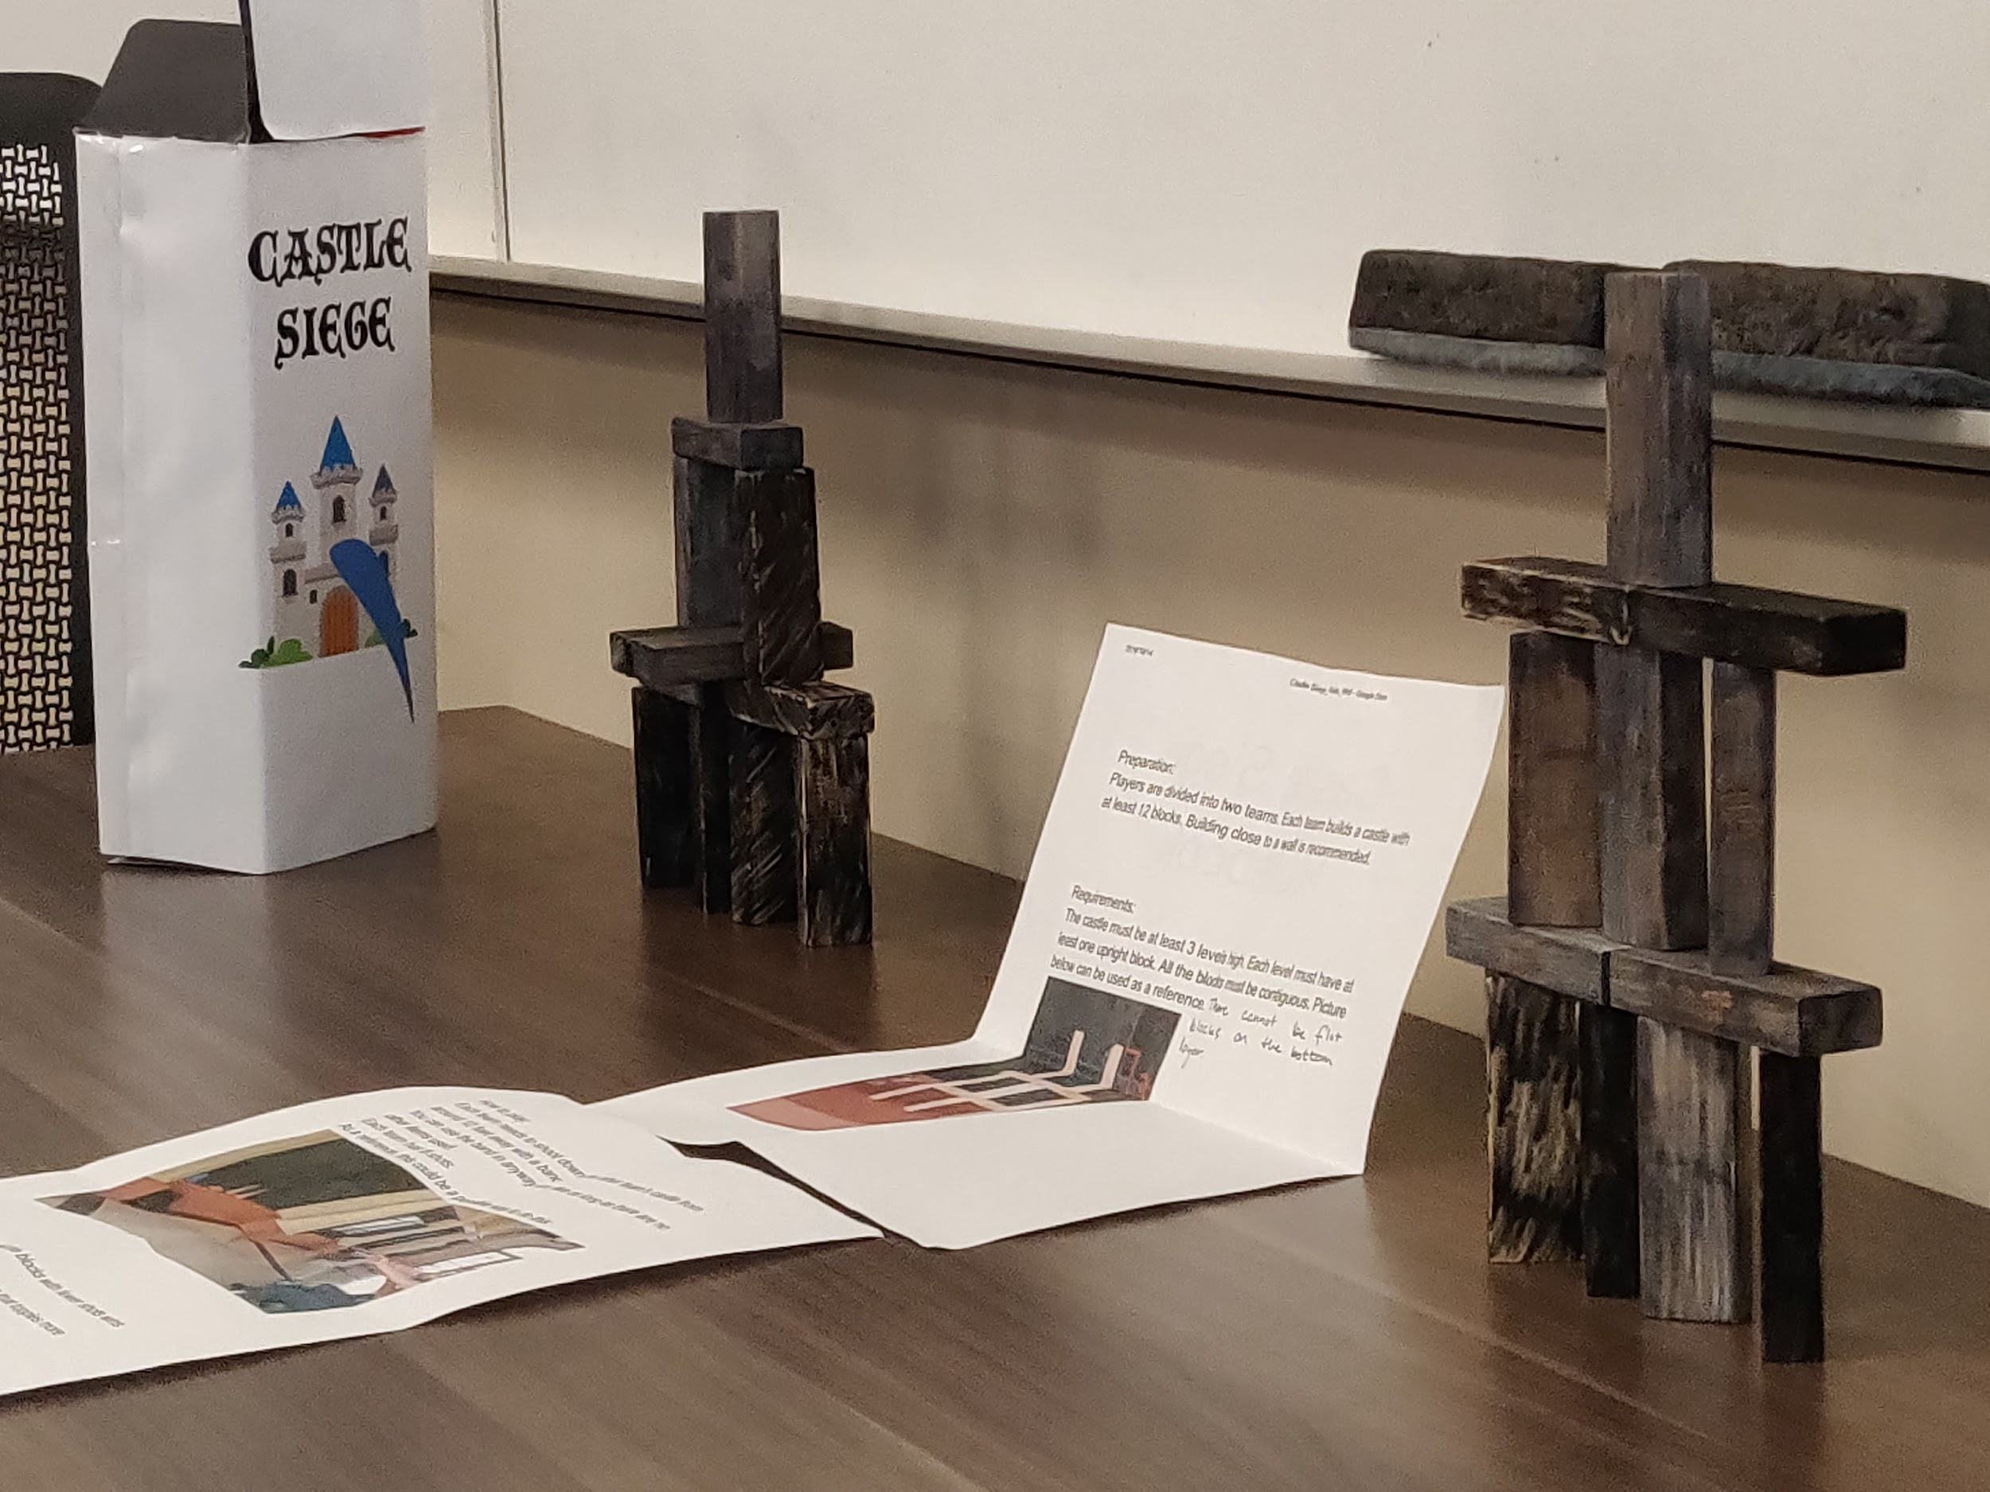

Responsibility:

Benjamin: Playtest & box decoration

Michael: Paint the blocks & rules

Zachary: Photo Journal

Zichang: Paint the blocks & rules